Southwest UK based Alt-rock/Shoegaze/Emo/Post-hardcore

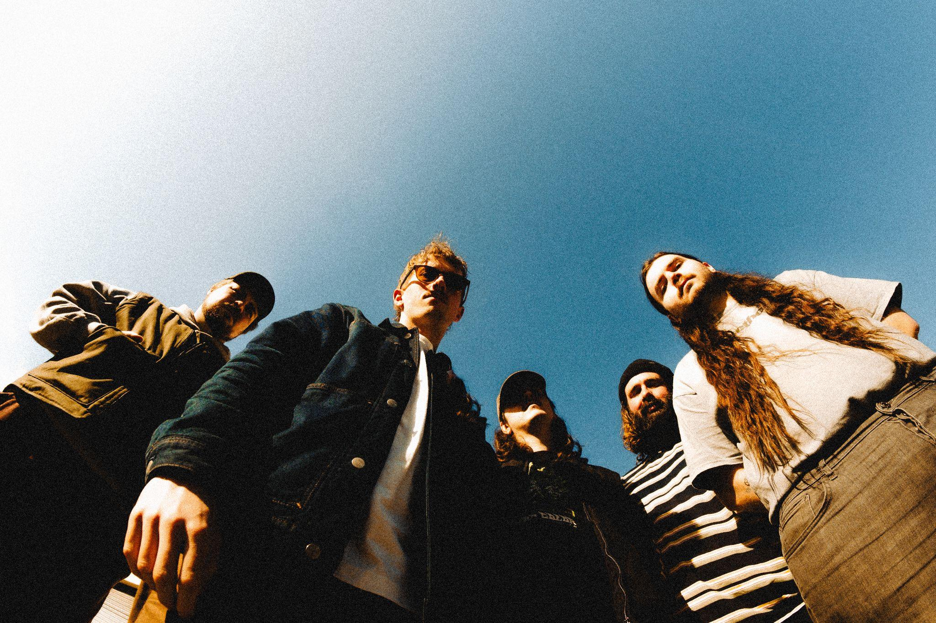

Oversize is an alternative band formed in the Southwest of England. While the band don’t shy away from their love of alternative 90’s music, Oversize have very little interest in being sonically tied to the past, their shared experience of writing and playing live together has found them carving out their own space within the alternative scene. Exploring dynamics within their music, songs drift between atmospheric textures to loud fuzzy riffs, magnifying and complimenting the personal and often venerable vocals.

Oversize have already had an impressive amount of live shows under their belt playing across the UK supporting the likes of Militarie Gun, Fiddlehead, Higher Power, Static Dress, Boston Manor, Modern Color to name a few.

Inbetween shows the band are currently working hard on the release of their debut LP. Produced and mixed by Lewis Johns at The Ranch Production House. It is already highly approved by heavyweights such as Daniel P Carter as they build momentum towards headliner status.

Listen to the debut LP ‘Vital Signs’ in full [*here.*](https://on.soundcloud.com/rTCxgqYqPAiAb48d6)

For enquiries please contact: oversizebandxl@gmail.com

[](https://www.instagram.com/oversizeband/)@oversizeband [](https://www.facebook.com/oversizeband)@oversizeband [](https://twitter.com/Oversizebandxl)@oversizebandxl